1)It gives null values for 2nd and 3rd query and the 1st query doesn’t change the productonhand number

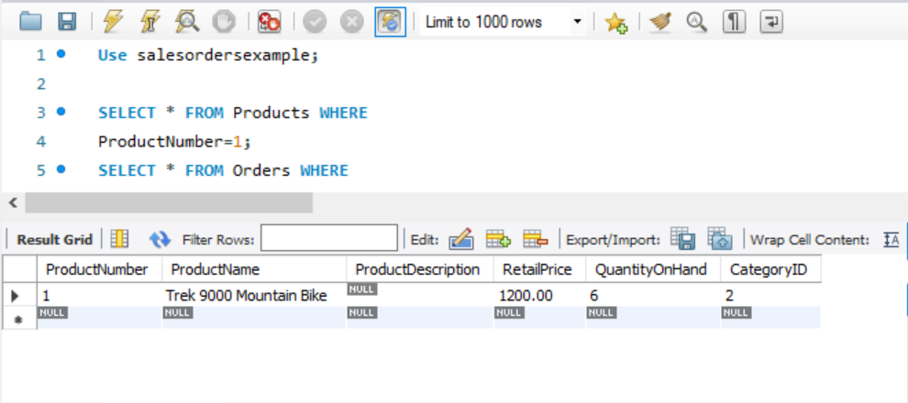

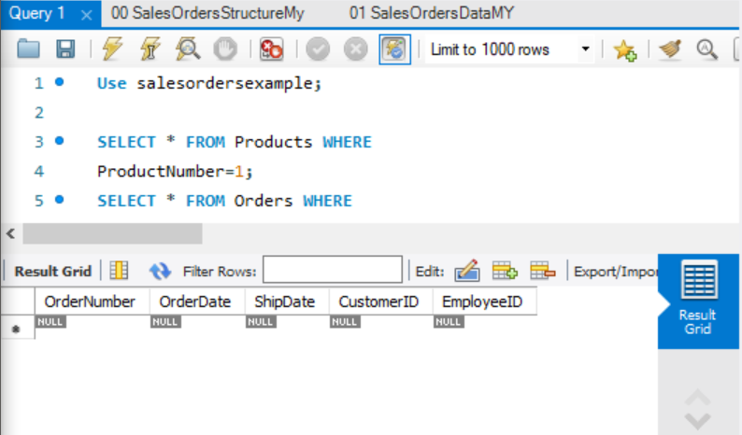

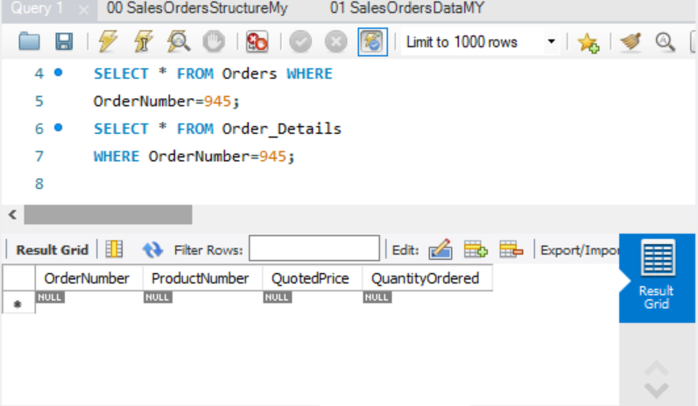

2)Still no change in output

3)Now all changes can be seen in their respective tables in right instance

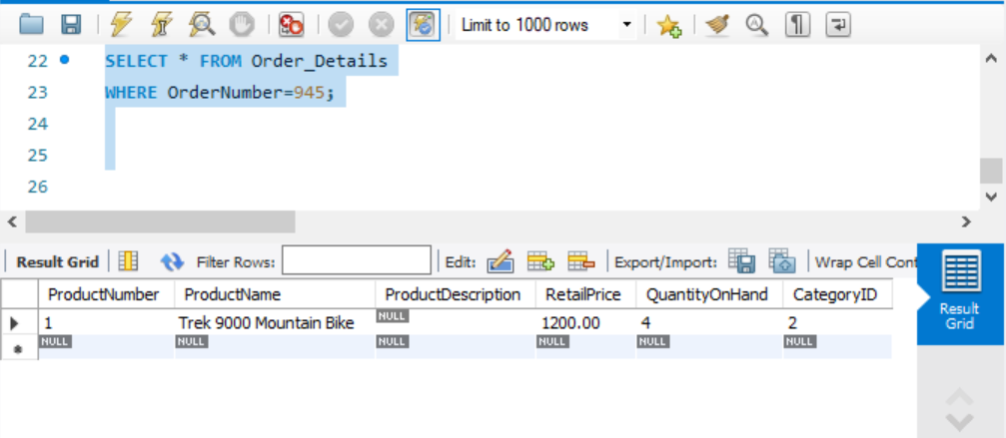

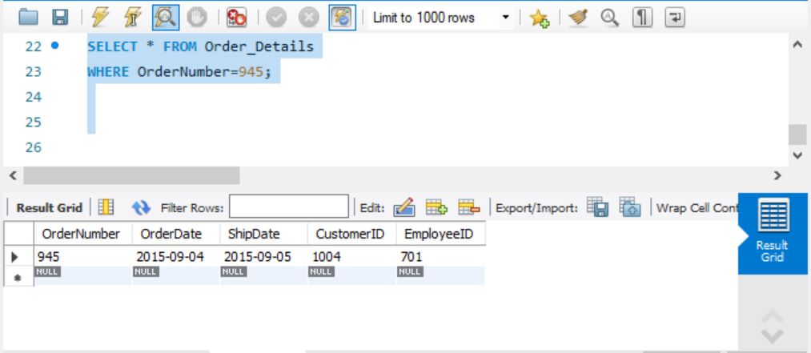

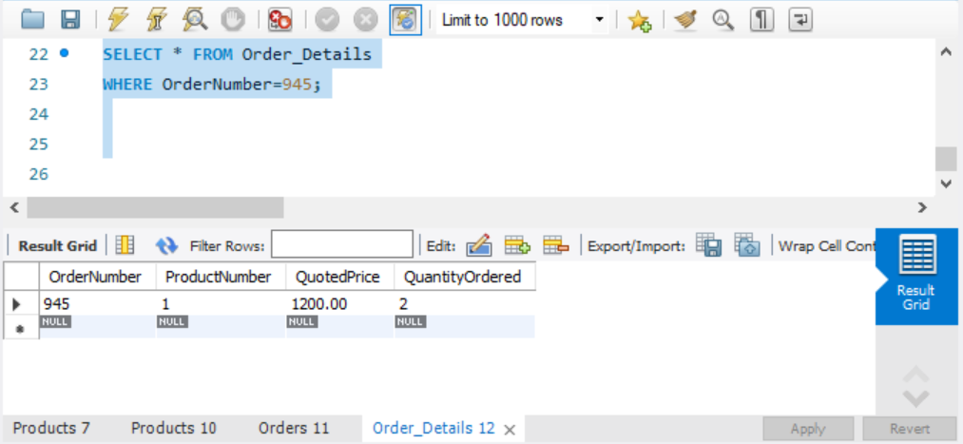

4)It still shows null

5) Now all of the query results come as expected (giving the exact same results which had been seen in pasrt3)

The isolation used here is REPEATABLE-READ.

For transaction1, it saw changed when both transaction2 and transaction1 had committed. For transaction2, it saw changes before committing but after writing the transaction 1’s statements on it.

Because the database is following isolation level of repeatable reads where any data read cannot change, and so no matter how many times it is read, it will find the previously read data in place, unchanged, and available to read.

It is an isolation level where a transaction reading the same item within the same transaction always returns the same result. Here phantom did pop up when we committed the change in transaction1.

According to SQL, phantoms are the new rows that pop up when new rows are added in middle of another transaction reads. It can occur even in the Repeatable read isolation level.